Testing, Validation & Security

Testing was performed to validate the automatic ticket classification, Category and Subcategory assignment, and email notification functionality of the system.

Test Scenario 1 – WiFi Ticket Classification

Test Input | Expected Result | Actual Result | Status
Caller: Abel Tuter  Short Description: WiFi not working in librar | Category → Network  Subcategory → Wi-Fi  Email sent to caller | Category → Network  Subcategory → Wi-Fi  Email sent to caller | Pass

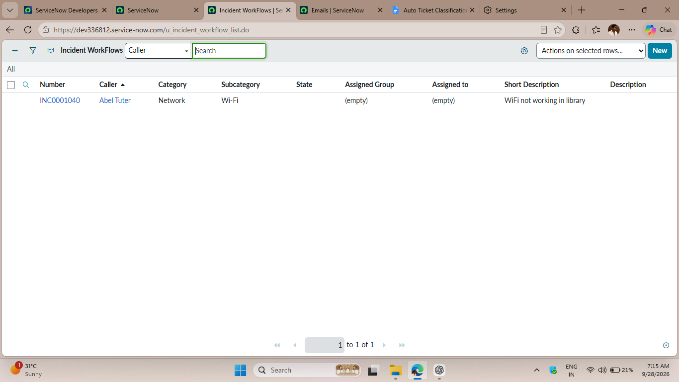

Email Notification Validation
The email notification was verified by checking the generated email record and previewing the confirmation message sent to the caller.

Figure 2: Email Notification Validation

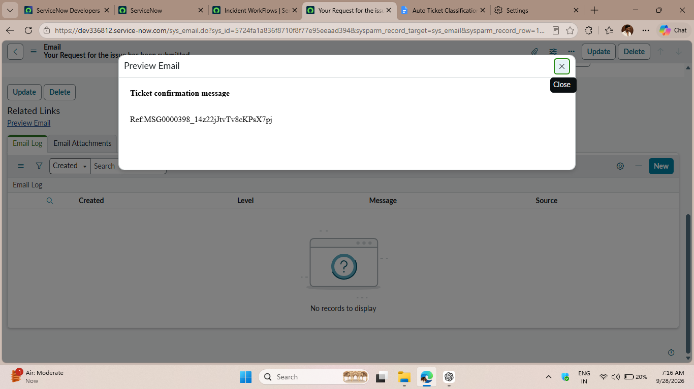

Test Scenario 2 – Projector Ticket Classification
Test Input | Expected Result | Actual Result | Status
aller: Abel Tuter  Short Description: Projector not turning on. | Category → Hardware  Subcategory → Projector  Email sent to caller | Category → Hardware  Subcategory → Projector  Email sent to caller | Pass

Figure 3: Test Scenario 2 – Automatic Projector Ticket Classification
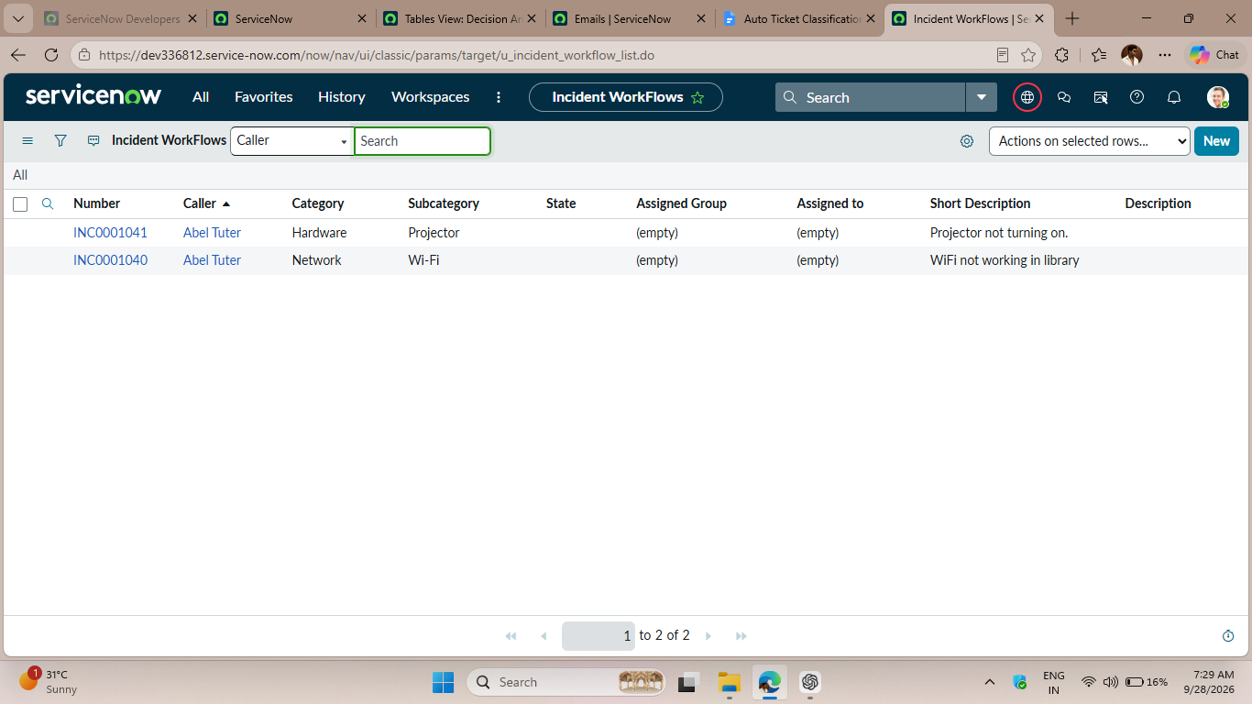

Testing Summary
The test scenarios confirmed that the workflow correctly classifies IT support tickets, assigns the appropriate Category and Subcategory, and sends an automated confirmation email to the caller.

